19.63: a) During the expansion, the Kelvin temperature doubles and and 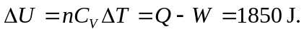 b) The final cooling is isochoric; 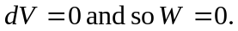 The temperature change is c) for the isothermal compression, 